37) Aim: To Design Non Deterministic Finite Automata using simulator to accept the string that start and end with different symbols over the input {a,b}.

Diagram:

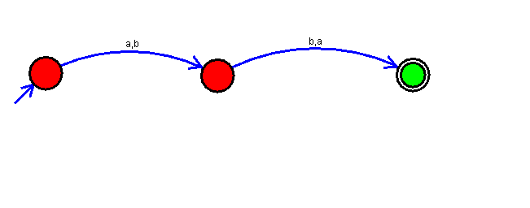

Result:

Successfully executed Non Deterministic Finite Automata using simulator to accept the string that start and end with different symbols over the input {a,b}.